**ASSIGNMENT NO.5.**

**Aim :-**

You have a business with several offices; you want to lease phone lines to connect them up with each other; and the phone company charges different amounts of money to connect different pairs of cities. You want a set of lines that connects all your offices with a minimum total cost. Solve the problem by suggesting appropriate data structures .

**Program Code:-**

#include <iostream>

#include<iomanip>

using namespace std;

const int MAX=10;

class EdgeList; //forward declaration

class Edge //USED IN KRUSKAL

{

int u,v,w;

public:

Edge(){} //Empty Constructor

Edge(int a,int b,int weight)

{

u=a;

v=b;

w=weight;

}

friend class EdgeList;

friend class PhoneGraph;

};

//---- EdgeList Class ----------

class EdgeList

{

Edge data[MAX];

int n;

public:

friend class PhoneGraph;

EdgeList()

{ n=0;}

void sort();

void print();

};

//----Bubble Sort for sorting edges in increasing weights' order ---//

void EdgeList::sort()

{

Edge temp;

for(int i=1;i<n;i++)

for(int j=0;j<n-1;j++)

if(data[j].w>data[j+1].w)

{

temp=data[j];

data[j]=data[j+1];

data[j+1]=temp;

}

}

void EdgeList::print()

{

int cost=0;

for(int i=0;i<n;i++)

{

cout<<"\n"<<i+1<<" "<<data[i].u<<"--"<<data[i].v<<" = "<<data[i].w;

cost=cost+data[i].w;

}

cout<<"\nMinimum cost of Telephone Graph = "<<cost;

}

//------------ Phone Graph Class---------------

class PhoneGraph

{

int data[MAX][MAX]={{0, 28, 0, 0, 0,10,0},

{28,0,16,0,0,0,14},

{0,16,0,12,0,0,0},

{0,0,12,0,22,0,18},

{0,0,0,22,0,25,24},

{10,0,0,0,25,0,0},

{0,14,0,18,24,0,0},

};

int n;

public:

PhoneGraph(int num)

{

n=num;

}

void readgraph();

void printGraph();

int mincost(int cost[],bool visited[]);

int prim();

void kruskal(EdgeList &spanlist);

int find(int belongs[], int vertexno);

void unionComp(int belongs[], int c1,int c2);

};

void PhoneGraph::readgraph()

{

cout<<"Enter Adjacency(Cost) Matrix: \n";

for(int i=0;i<n;i++)

{

for(int j=0;j<n; j++)

cin>>data[i][j];

}

}

void PhoneGraph::printGraph()

{

cout<<"\nAdjacency (COST) Matrix: \n";

for(int i=0;i<n;i++)

{

for(int j=0;j<n;j++)

{

cout<<setw(3)<<data[i][j];

}

cout<<endl;

}

}

int PhoneGraph::mincost(int cost[],bool visited[]) //finding vertex with minimum cost

{

int min=9999,min_index; //initialize min to MAX value(ANY) as temporary

for(int i=0;i<n;i++)

{

if(visited[i]==0 && cost[i]<min)

{

min=cost[i];

min_index=i;

}

}

return min_index; //return index of vertex which is not visited and having minimum cost

}

int PhoneGraph::prim()

{

bool visited[MAX];

int parents[MAX]; //storing vertices

int cost[MAX]; //saving minimum cost

for(int i=0;i<n;i++)

{

cost[i]=9999; //set cost as infinity/MAX_VALUE

visited[i]=0; //initialize visited array to false

}

cost[0]=0; //starting vertex cost

parents[0]=-1; //make first vertex as a root

for(int i=0;i<n-1;i++)

{

int k=mincost(cost,visited); //minimum cost elemets index

visited[k]=1; //set visited

for(int j=0;j<n;j++)//for adjacent verices comparision

{

if(data[k][j] && visited[j]==0 && data[k][j] < cost[j])

{

parents[j]=k;

cost[j]=data[k][j];

}

}

}

cout<<"Minimum Cost Telephone Map:\n";

for(int i=1;i<n;i++)

{

cout<<i<<" -- "<<parents[i]<<" = "<<cost[i]<<endl;

}

int mincost=0;

for (int i = 1; i < n; i++)

mincost+=cost[i]; //data[i][parents[i]];

return mincost;

}

//------- Kruskal's Algorithm

void PhoneGraph::kruskal(EdgeList &spanlist)

{

int belongs[MAX]; //Separate Components at start (No Edges, Only vertices)

int cno1,cno2; //Component 1 & 2

EdgeList elist;

for(int i=1;i<n;i++)

for(int j=0;j<i;j++)

{

if(data[i][j]!=0)

{

elist.data[elist.n]=Edge(i,j,data[i][j]); //constructor for initializing edge

elist.n++;

}

}

elist.sort(); //sorting in increasing weight order

for(int i=0;i<n;i++)

belongs[i]=i;

for(int i=0;i<elist.n;i++)

{

cno1=find(belongs,elist.data[i].u); //find set of u

cno2=find(belongs,elist.data[i].v); ////find set of v

if(cno1!=cno2) //if u & v belongs to different sets

{

spanlist.data[spanlist.n]=elist.data[i]; //ADD Edge to spanlist

spanlist.n=spanlist.n+1;

unionComp(belongs,cno1,cno2); //ADD both components to same set

}

}

}

void PhoneGraph::unionComp(int belongs[],int c1,int c2)

{

for(int i=0;i<n;i++)

{

if(belongs[i]==c2)

belongs[i]=c1;

}

}

int PhoneGraph::find(int belongs[],int vertexno)

{

return belongs[vertexno];

}

//--------- MAIN PROGRAM-----------------------------------

int main() {

int vertices,choice;

EdgeList spantree;

cout<<"Enter Number of cities: ";

cin>>vertices;

PhoneGraph p1(vertices);

//p1.readgraph();

do

{

cout<<"\n1.Find Minimum Total Cost(By Prim's Algorithm)"

<<"\n2.Find Minimum Total Cost(by Kruskal's Algorithms)"

<<"\n3.Re-Read Graph(INPUT)"

<<"\n4.Print Graph"

<<"\n0. Exit"

<<"\nEnter your choice: ";

cin>>choice;

switch(choice)

{

case 1:

cout<<" Minimum cost of Phone Line to cities is: "<<p1.prim();

break;

case 2:

p1.kruskal(spantree);

spantree.print();

break;

case 3:

p1.readgraph();

break;

case 4:

p1.printGraph();

break;

default:

cout<<"\nWrong Choice!!!";

}

}while(choice!=0);

return 0;

}

/* Sample INPUT: vertices =7

* {{0, 28, 0, 0, 0,10,0},

{28,0,16,0,0,0,14},

{0,16,0,12,0,0,0},

{0,0,12,0,22,0,18},

{0,0,0,22,0,25,24},

{10,0,0,0,25,0,0},

{0,14,0,18,24,0,0},

};

Minimum Cost: 99

*/

**Output Screenshots:-**

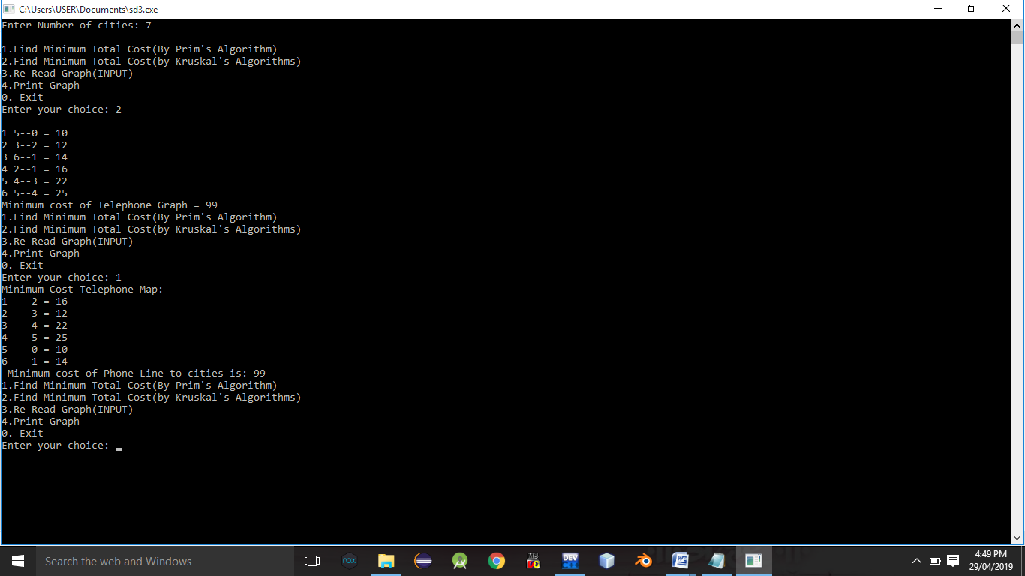

**Conclusion:-** Thus,we have studied implementation of kruskal’s algorithm.